Click on Start

Type: cer

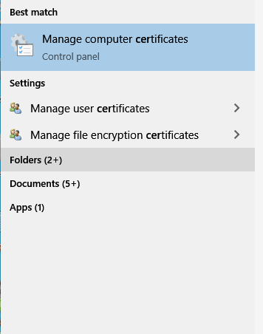

Open the Trusted Root Certification Authorities/Certificates

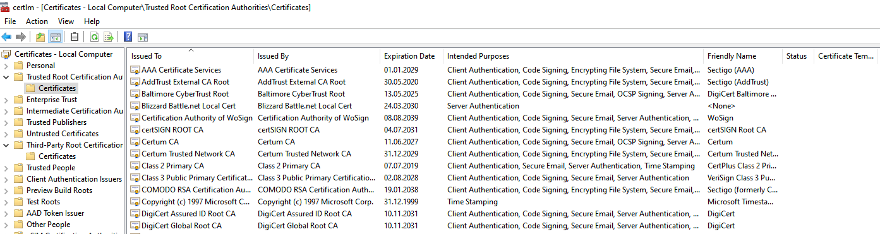

Right Click on the White/Blank Space
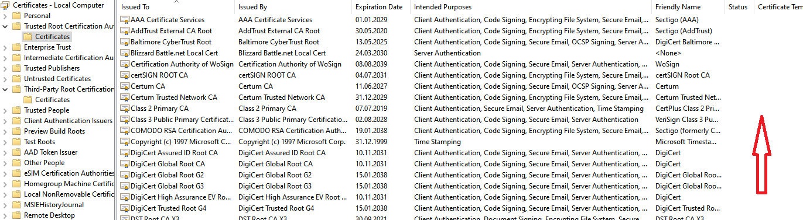

All task /Import
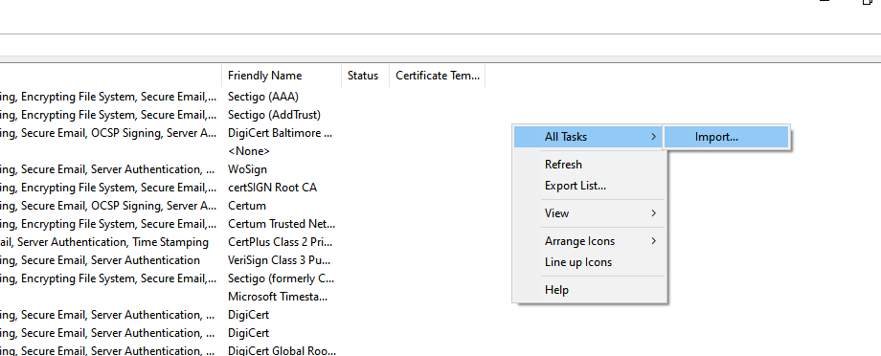

Import the certificate

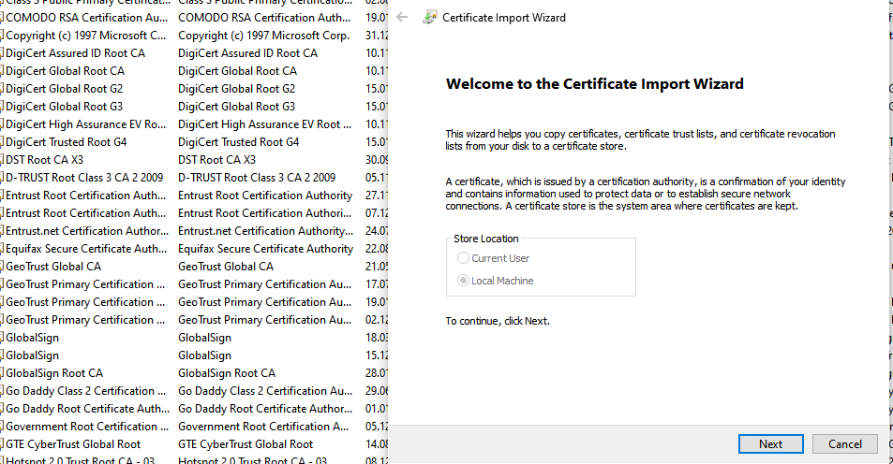

/Same as above to import the same certificate in Third-Party-Root Certification Authorities/Certificates

